18053

Study of MDS Algorithm
Q. Demontrate MDS algorithm in python.
Aim : To write a program to demonstrate MDS Algorithm in python. Program:
import hashlib str1="syit class"
md5hashvalue=hashlib.md5() print(md5hashvalue) md5hashvalue.update(str1.encode('utf-8')) md5hashvalue messagedigest=md5hashvalue.hexdigest() messagedigest
print(messagedigest)

Result:
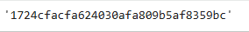

Conclusion: The above program has been executed successfully.

